**--EN ÇOK SATAN ÜRÜN ANALİZİ**

SELECT

p.product_name,

SUM(od.quantity) AS TotalQuantity

FROM

order_details od

JOIN

products p ON od.product_id = p.product_id

GROUP BY

p.product_name

ORDER BY

TotalQuantity DESC

LIMIT 10;

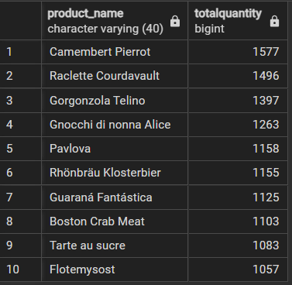

**--MÜŞTERİ SEGMENTASYONU**

WITH CustomerTotals AS (

SELECT

c.customer_id,

c.company_name,

SUM(od.quantity * od.unit_price) AS TotalSpent

FROM

orders o

JOIN

order_details od ON o.order_id = od.order_id

JOIN

customers c ON o.customer_id = c.customer_id

GROUP BY

c.customer_id, c.company_name

),

Percentiles AS (

SELECT

PERCENTILE_CONT(0.33) WITHIN GROUP (ORDER BY TotalSpent) AS P33,

PERCENTILE_CONT(0.66) WITHIN GROUP (ORDER BY TotalSpent) AS P66

FROM

CustomerTotals

)

SELECT

ct.customer_id,

ct.company_name,

ct.TotalSpent,

CASE

WHEN ct.TotalSpent > p.P66 THEN 'Üst Segment'

WHEN ct.TotalSpent > p.P33 THEN 'Orta Sehment'

ELSE 'Alt Segment'

END AS CustomerCategory

FROM

CustomerTotals ct

JOIN

Percentiles p ON 1=1

ORDER BY

ct.TotalSpent DESC;

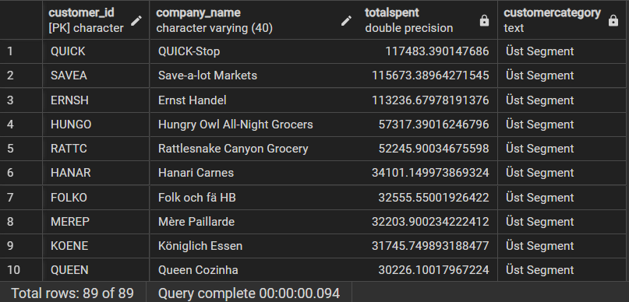

**--SİPARİŞ TRENDLERİ**

SELECT

TO_CHAR(o.order_date, 'YYYY-MM') AS YearMonth,

COUNT(o.order_id) AS OrderCount,

SUM(od.quantity * od.unit_price) AS TotalSales

FROM

orders o

JOIN

order_details od ON o.order_id = od.order_id

GROUP BY

YearMonth

ORDER BY

YearMonth;

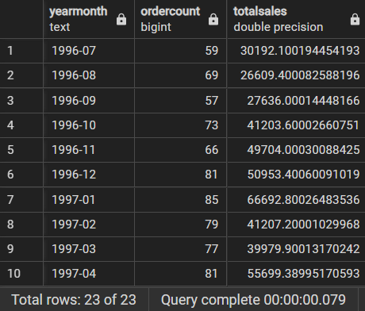

**--ÜRÜN ANALİZİ**

SELECT

product_name,

unit_price,

CASE

WHEN unit_price >= 150 THEN 'Yüksek'

WHEN unit_price BETWEEN 50 AND 149.99 THEN 'Orta'

ELSE 'Düşük'

END AS price_category

FROM Products

WHERE unit_price >= 150 OR unit_price < 50

ORDER BY unit_price DESC;

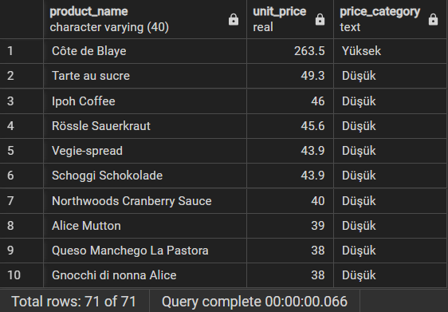

**--ORTALAMA FİYATIN ÜZERİNDEKİ ÜRÜNLER**

SELECT product_name, unit_price

FROM products

WHERE unit_price > (

SELECT AVG(unit_price)

FROM products

);

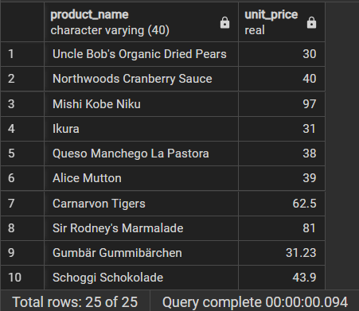

**--EN YÜKSEK SİPARİŞ DEĞERLERİ**

SELECT

o.order_id,

SUM(od.quantity * od.unit_price * (1 - od.discount)) AS order_value,

o.order_date,

o.ship_country

FROM

orders o

JOIN

order_details od ON o.order_id = od.order_id

GROUP BY

o.order_id, o.order_date, o.ship_country

ORDER BY

order_value DESC

LIMIT 10;

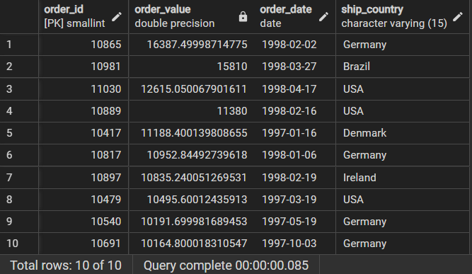

**--AYLIK VE YILLIK ORTALAMA SİPARİŞ DEĞERLERİ**

SELECT

EXTRACT(YEAR FROM orders.order_date) AS year,

EXTRACT(MONTH FROM orders.order_date) AS month,

AVG(order_details.quantity * order_details.unit_price * (1 - order_details.discount)) AS average_order_value

FROM order_details

JOIN orders ON orders.order_id = order_details.order_id

GROUP BY

EXTRACT(YEAR FROM orders.order_date),

EXTRACT(MONTH FROM orders.order_date)

ORDER BY

year DESC,

month DESC;

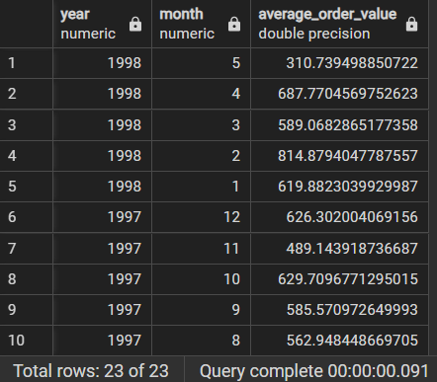

**--ÜLKE BAZINDA TOPLAM SİPARİŞ DEĞERLERİ**

SELECT

SUM(order_details.product_id * order_details.unit_price - order_details.discount) AS order_value,

orders.ship_country

FROM order_details

JOIN orders on orders.order_id = order_details.order_id

GROUP BY orders.ship_country

ORDER BY order_value DESC;

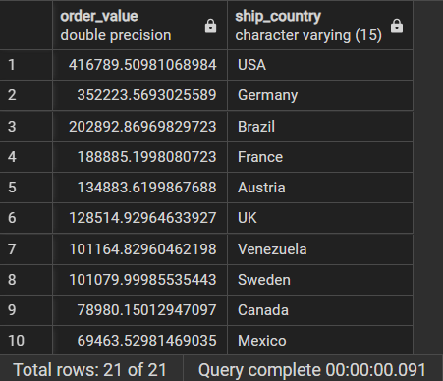

**--ÜLKE BAZINDA ORTALAMA SİPARİŞ DEĞERLERİ**

SELECT

AVG(order_details.product_id * order_details.unit_price - order_details.discount) AS order_value,

orders.ship_country

FROM order_details

JOIN orders on orders.order_id = order_details.order_id

GROUP BY orders.ship_country

ORDER BY order_value DESC;

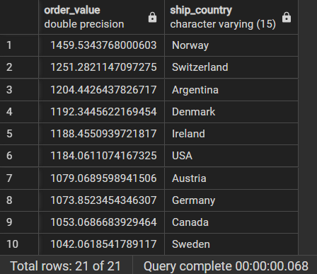

**--TESLİMAT SÜRELERİNE GÖRE KARGO FİRMALARININ PERFORMANS ANALİZİ**

SELECT

ship_name,

AVG((shipped_date - order_date)::numeric) AS average_delivery_days,

CASE

WHEN AVG((shipped_date - order_date)::numeric) <= 2 THEN 'İyi'

WHEN AVG((shipped_date - order_date)::numeric) <= 5 THEN 'Orta'

ELSE 'Kötü'

END AS delivery_rating

FROM

orders

GROUP BY

ship_name;

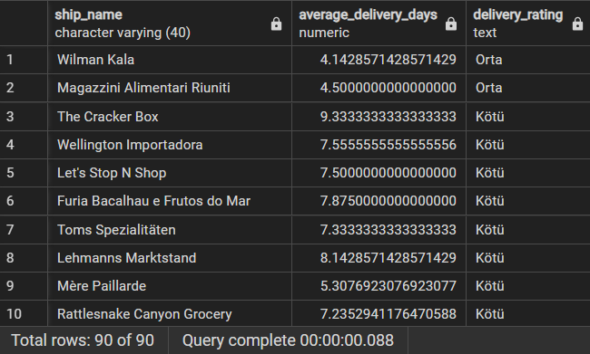

**--MÜŞTERİ MEMNUNİYET ANALİZİ**

SELECT

o.customer_id,

c.company_name,

COUNT(o.order_id) AS order_count,

SUM(od.quantity * od.unit_price) AS total_spent,

AVG(od.quantity * od.unit_price) AS average_order_value,

CASE

WHEN COUNT(o.order_id) = 1 THEN 'Yeni Müşteri'

WHEN COUNT(o.order_id) BETWEEN 2 AND 5 THEN 'Orta'

ELSE 'Sadık Müşteri'

END AS customer_type

FROM

orders o

JOIN

order_details od ON o.order_id = od.order_id

JOIN

customers c ON o.customer_id = c.customer_id

GROUP BY

o.customer_id, c.company_name

ORDER BY

order_count DESC;

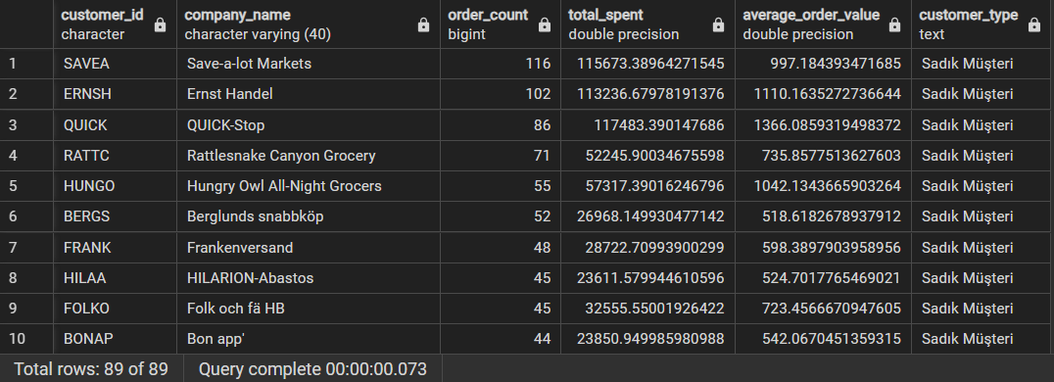

**--KAMPANYA PERFORMANSI**

SELECT

CASE

WHEN od.discount > 0 THEN 'Kampanyalı'

ELSE 'Kampanyasız'

END AS campaign_type,

COUNT(o.order_id) AS order_count,

SUM(od.quantity * od.unit_price * (1 - od.discount)) AS total_sales,

AVG(od.quantity * od.unit_price * (1 - od.discount)) AS average_order_value

FROM

orders o

JOIN

order_details od ON o.order_id = od.order_id

GROUP BY

CASE

WHEN od.discount > 0 THEN 'Kampanyalı'

ELSE 'Kampanyasız'

END;

